Infosys Springboard Virtual Internship 7.0

Completion Report
Team Details
Batch Number: 01
Start date: 29 June 2026
Names:
1. Harsha Priya Parimi
2. Preeti Prakash Devaraddi
3. Ragi Dixitha
4. Pydi Sri Vaishnavi
5. Ramesh Priyadarshni
Internship Duration: 8 Weeks

1. Project Title
AI POWERED INTELLIGENT SALES FORECASTING PLATFORM USING PREDICTIVE ANALYTICS.

2. Project Objective
- To develop an AI-powered system for predicting future sales.
- To analyze historical sales data and identify important sales patterns and trends.
- To improve the accuracy of sales forecasting using AI and machine learning techniques.
- To help businesses make data-driven decisions based on predicted sales.
- To reduce manual effort involved in sales analysis and forecasting.
- To support better inventory, resource, and sales planning.
- To provide useful insights that can help organizations improve sales performance and business growth.

3. Project description in detail
The AI-Powered Intelligent Sales Forecasting project is developed to help businesses predict future sales using Artificial Intelligence and Machine Learning techniques. The system analyzes historical sales data to identify patterns, trends, and sales behavior, and uses these insights to forecast future sales.
The project reduces the need for manual sales analysis and helps organizations make data-driven decisions. It provides useful insights that can support sales planning, inventory management, resource allocation, and setting future sales targets.
The system integrates data processing, machine learning, database management, backend services, and a user-friendly interface to provide an efficient sales forecasting solution. Overall, the project aims to improve forecasting accuracy, save time, and help businesses enhance their sales performance and decision-making process.

4. Timeline Overview
Week | Activities Planned | Activities Completed
Week 1 | Project introduction, requirement analysis, system planning, and technology selection | Requirements were analyzed, project workflow was planned, and the technology stack was finalized.
Week 2 | Lead Management & Intelligence: Design lead management and AI-based lead analysis features | Lead management features and basic lead intelligence functionality were implemented.
Week 3 | Company Analysis: Develop company information analysis and insights | Company analysis features were implemented and integrated with the system.
Week 4 | Sales Forecasting: Develop AI/ML-based sales prediction and forecasting functionality | Sales forecasting functionality was developed and integrated with the application.
Week 5 | AI Sales Assistant: Implement AI-based assistance and sales-related recommendations | AI sales assistant features were implemented and connected with the required services.
Week 6 | CRM Integration and Dashboard/Reporting: Integrate CRM functionality and provide useful sales insights | CRM integration and dashboard/reporting features were implemented and connected with the application.
Week 7 | Testing, Debugging & DevOps: Perform functional testing, fix issues, and containerize/deploy the application | System testing was completed, identified issues were fixed, and Docker/DevOps activities were carried out.
Week 8 | Documentation, Presentation Preparation & Submission | Project documentation was completed, presentation slides were prepared, the project was reviewed, and the final submission was completed.

5a. Key Milestones
Milestone | Description | Date Achieved
Project Kickoff | Project requirements, objectives, team roles, workflow, and technology stack were finalized. | 17-July-2026
Prototype/First Draft | The initial prototype was developed with the basic system structure, database, user interface, and core functionalities. | 22-July-2026
Mid-Term Review | The developed modules were reviewed and tested, project progress was evaluated, and necessary improvements were identified. | 30-July-2026
Final Submission | All modules were completed and integrated, testing and DevOps activities were finalized, and the project documentation was completed and submitted. | 16-August-2026
Presentation | The final presentation was prepared, and the completed project was demonstrated to the evaluators. | 18-August-2026

5b. Project execution details
The AI-Powered Intelligent Sales Forecasting project was executed in a systematic manner over eight weeks. The development process involved requirement analysis, system design, implementation of the major modules, testing, DevOps activities, and final documentation.
- Requirement Analysis & Planning: Project requirements, objectives, workflows, and team responsibilities were identified and finalized.
- System Design & Prototype: The basic architecture, database structure, user interface, and initial prototype were developed.
- Module Development: The six major modules were implemented, including lead management, company analysis, sales forecasting, AI sales assistance, CRM integration, and dashboard/reporting.
- Integration: The developed modules were integrated with the backend, database, AI components, and frontend to form a complete application.
- Testing & Debugging: Functional testing was performed to verify the system features, identify errors, and ensure that the application worked as expected.
- DevOps Implementation: Docker and related deployment activities were carried out to provide a consistent and manageable application environment.
- Documentation & Presentation: The final project documentation was prepared, presentation slides were created, and the complete system was reviewed and prepared for final submission and demonstration.

6. Snapshots / Screenshots

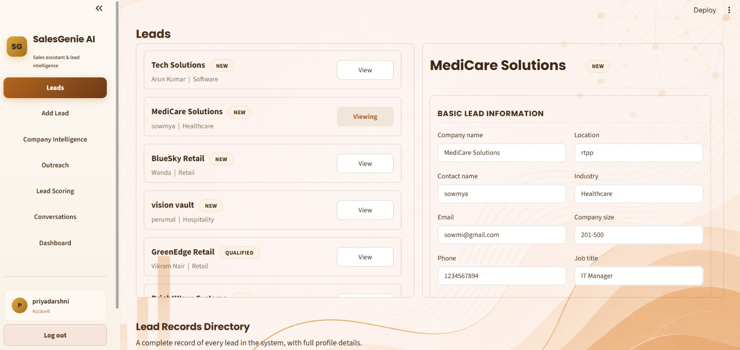

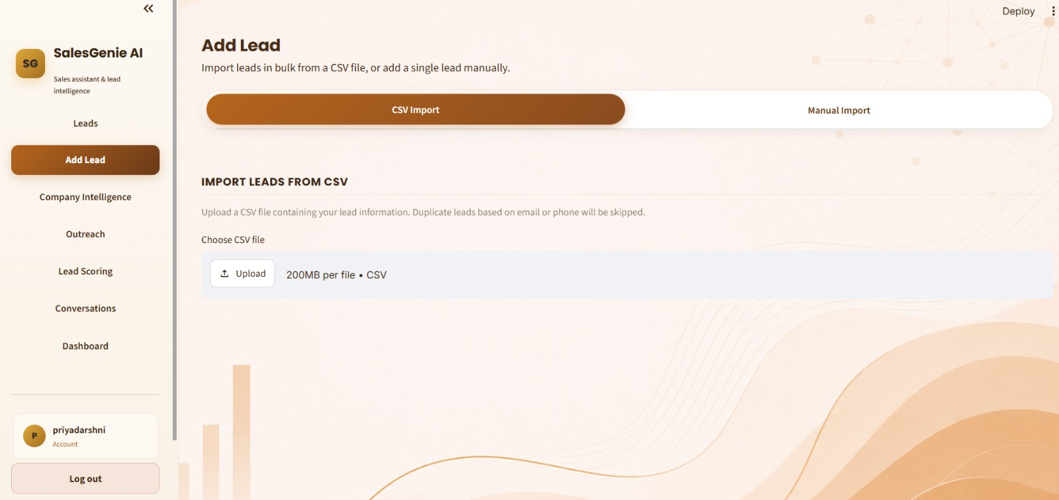
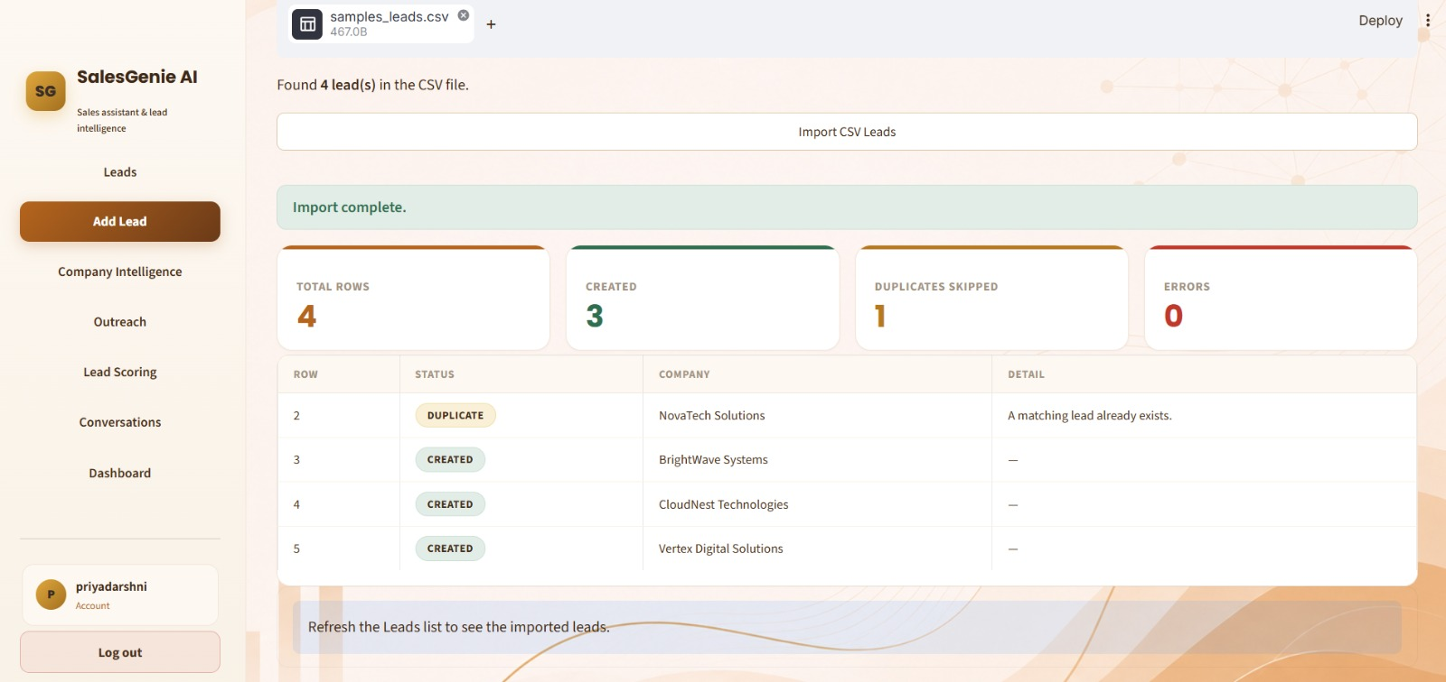

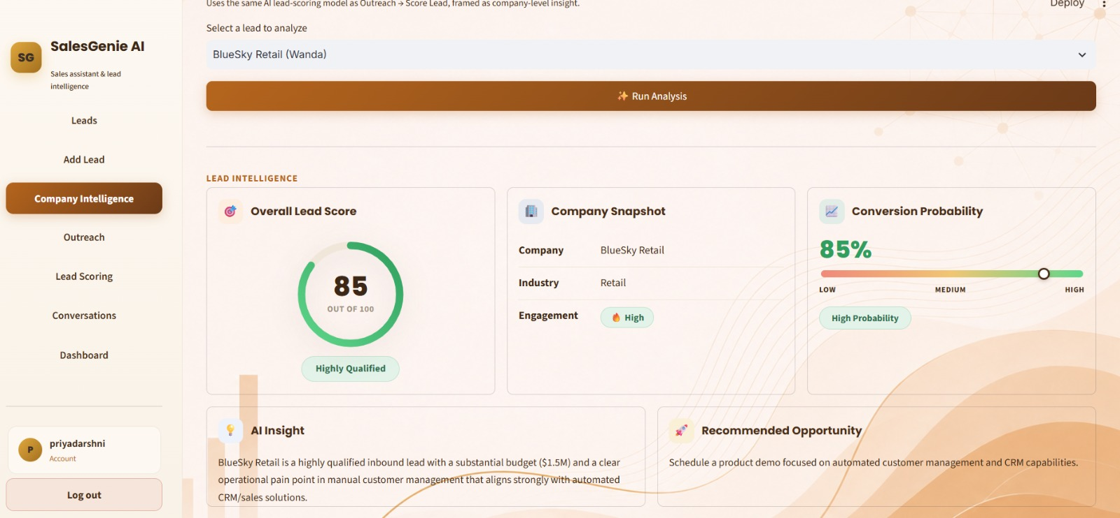
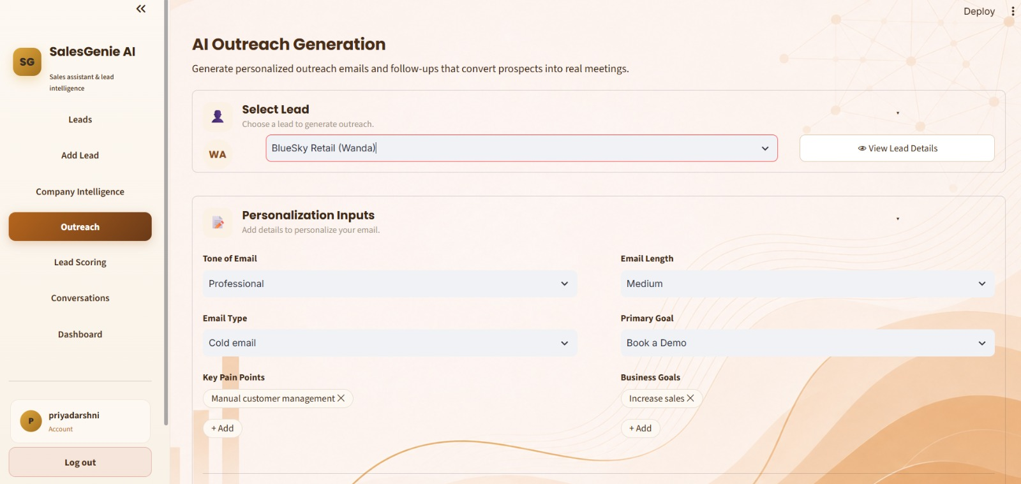

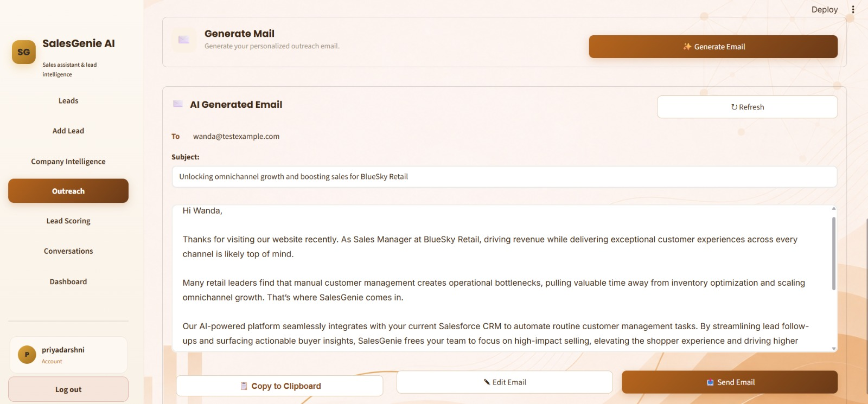
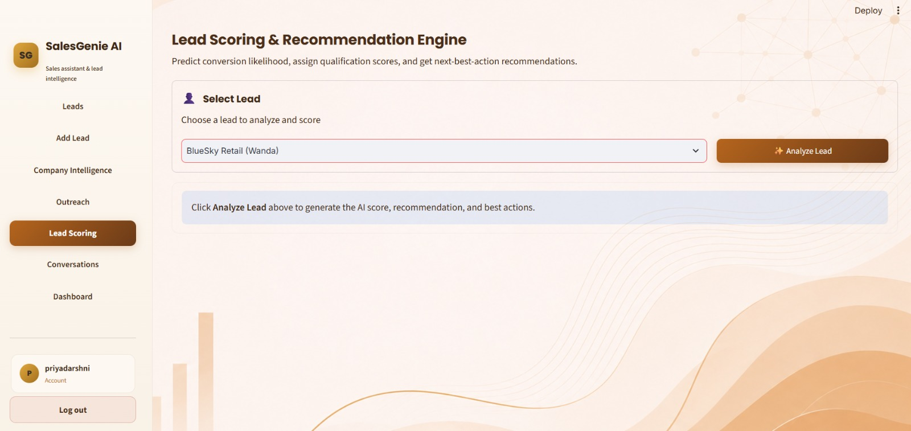

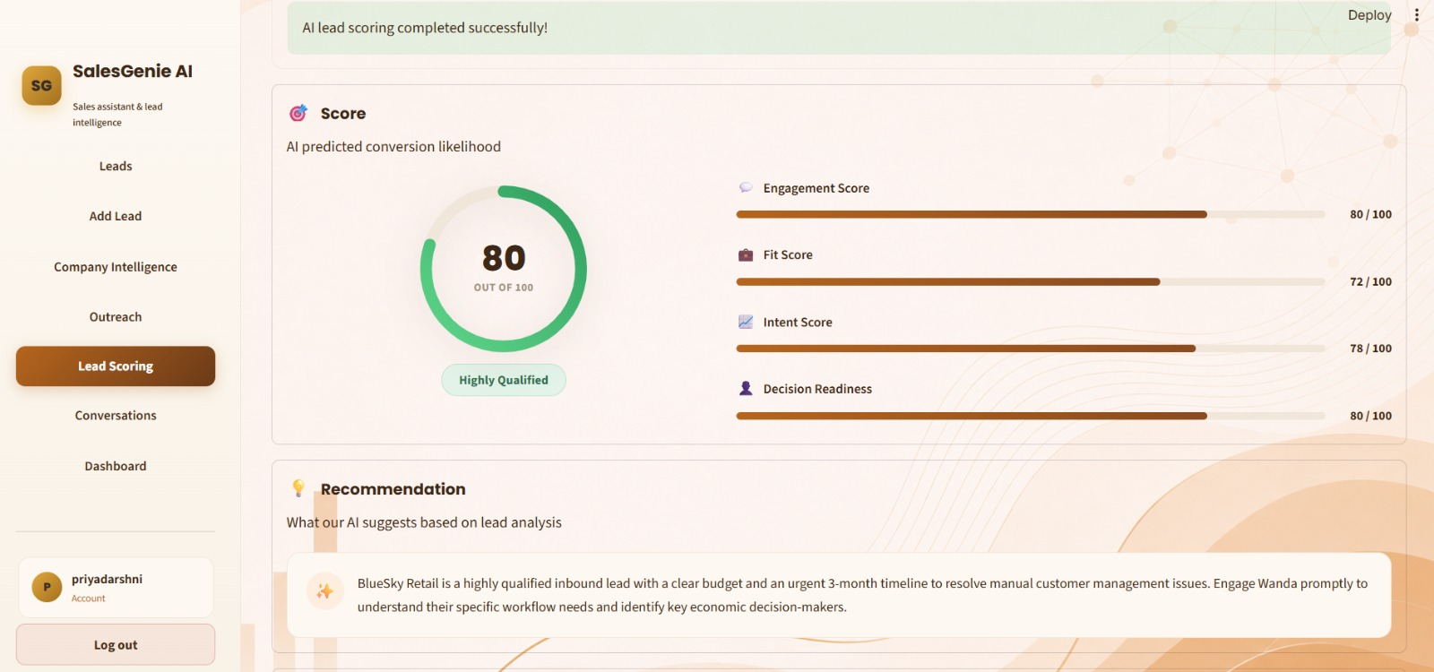
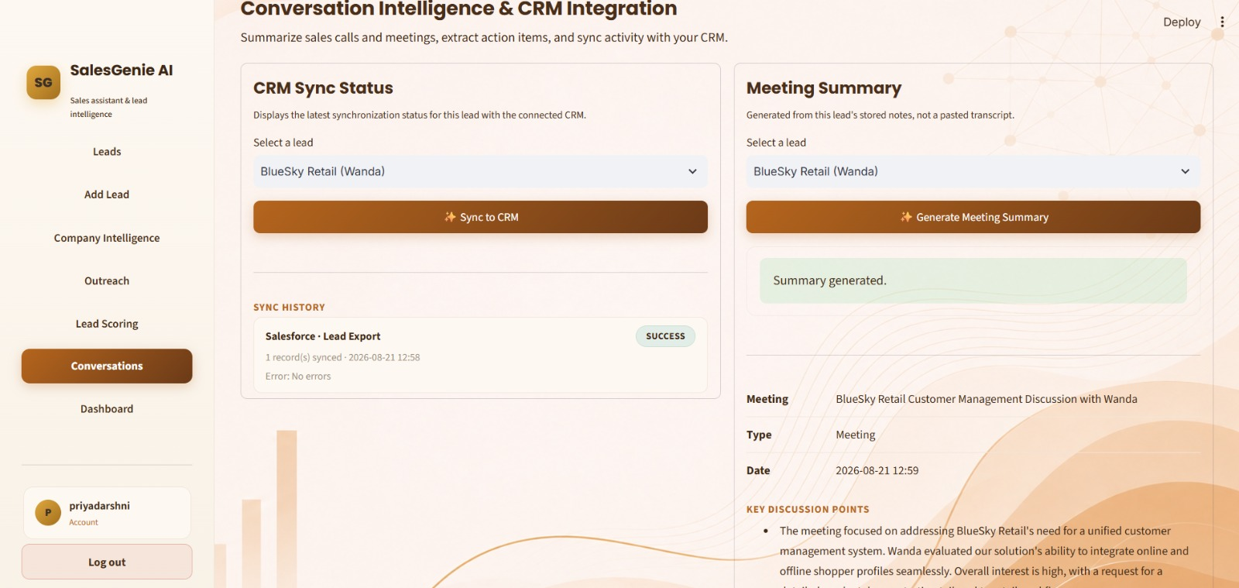

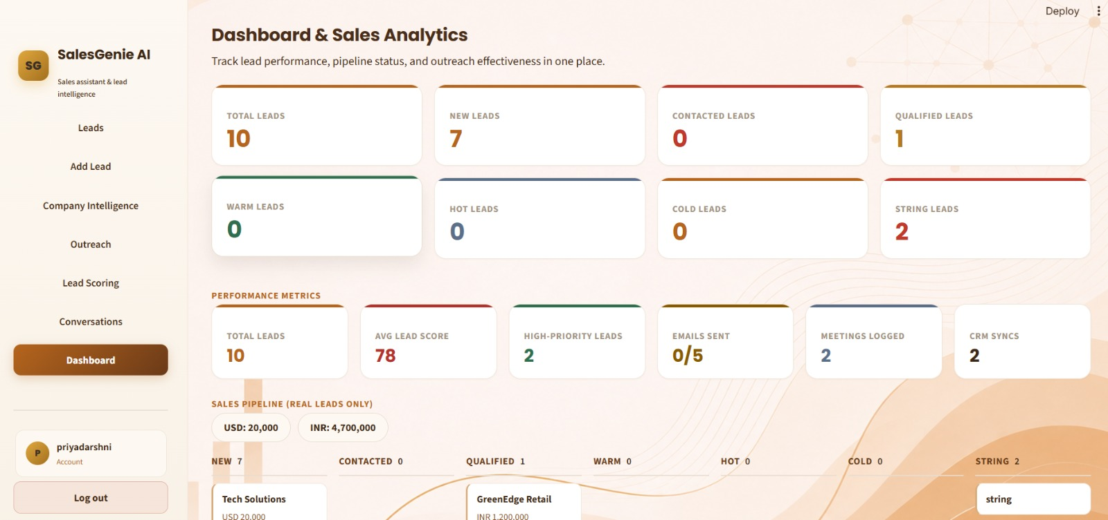

7. Challenges Faced
1. Google Login Integration: We faced difficulties while connecting and configuring the “Connect with Google” login button with the application.
2. API Integration for CSV Upload: We faced challenges while integrating the API required for CSV file upload and processing.
3. Module Integration: Integrating the different modules and ensuring proper communication between the frontend, backend, database, and AI components was challenging.

8. Learnings & Skills Acquired
- Machine Learning & AI: Knowledge of machine learning algorithms, data preprocessing, model training, and sales forecasting.
- API Integration: Understanding REST APIs and how to connect frontend, backend, and external services.
- Database Management: Knowledge of database design, SQL, and handling application data.
- Testing & DevOps: Basic knowledge of software testing, debugging, Git, Docker, and application deployment.
- Teamwork & Communication: Ability to collaborate with team members, explain technical work, and manage project responsibilities effectively.

9. Testimonials from team
The project received positive feedback from our project mentor, faculty, and team members. The mentor appreciated our effort in developing an AI-powered solution for sales forecasting and encouraged us to improve its accuracy and usability. Faculty members appreciated the practical application of Artificial Intelligence and Machine Learning in solving a real-world business problem. Our team members also found that effective communication, teamwork, and collaboration helped us overcome technical challenges and complete the project successfully. Overall, the feedback motivated us to improve the system and gain practical knowledge throughout the project development process.

10. Conclusion
The AI-Powered Intelligent Sales Forecasting project successfully demonstrates how Artificial Intelligence and Machine Learning can be used to analyze historical sales data and predict future sales. The project integrates multiple modules, including lead management, company analysis, sales forecasting, AI assistance, CRM integration, and dashboard reporting, to provide a complete and intelligent sales support system. Through this project, we gained practical knowledge in AI, machine learning, API integration, database management, testing, and DevOps. Overall, the system helps reduce manual effort, improve sales planning, and support data-driven business decisions.

11. Acknowledgements
We would like to express our sincere gratitude to our project mentor and faculty members for their continuous guidance, valuable suggestions, and support throughout the development of our AI-Powered Intelligent Sales Forecasting project. We also thank our team members for their cooperation, effective communication, and contribution to completing the different modules of the project. Finally, we are grateful to our institution for providing us with the resources and opportunity to gain practical knowledge and experience through this project.

